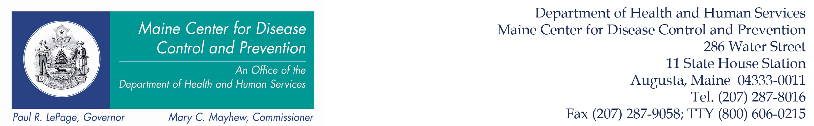
Tel. (207) 287-5671 Health Inspection Program Fax (207) 287-3165

The Person In Charge MUST exclude food employees from the food establishment and duties when:

- A food employee is diagnosed with Salmonella typhi, Shigella spp., Escherichia coli O157:H7, Norovirus or Hepatitis A virus, OR
- A food employee has one of the above illnesses and is serving a highly susceptible population, i.e. nursing home, OR
- A food employee is jaundiced.

The Person In Charge MAY remove an exclusion when:

- The Person In Charge obtains approval from the Health Inspection Program, AND
- A written medical document from a licensed physician is provided to the Person In Charge stating that the Employee may work in an unrestricted capacity in the food establishment.

Web Site Address: http://www.maine.gov/healthinspection

